Grading the Professor
Problem 1: Describe the course evaluation scores. Calculate some summary statistics and display the data using a histogram (with proper colors, labels, titles, etc.)
> print("Summary of Variable 'score':"); summary(score);
[1] "Summary of Variable 'score':"
Min. 1st Qu. Median Mean 3rd Qu. Max.
2.300 3.800 4.300 4.175 4.600 5.000
> print(paste("Standard Deviation:", sd(score), sep = " "))
[1] "Standard Deviation: 0.543864521209176"
> hist(score, xlab = "Eval Score", ylab = "Frequency", col = "green", main = "Histogram of Evaluation Scores")

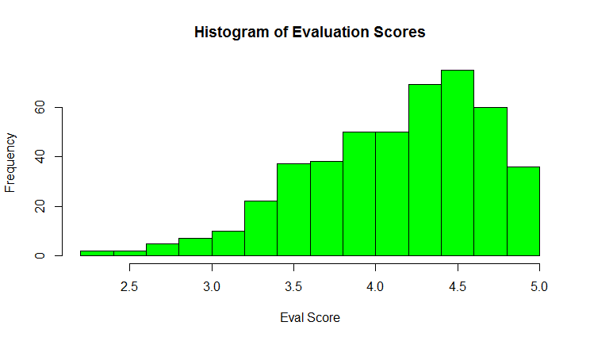
Problem 2: Visualize the relationship between course evaluation scores and the “beauty” of the professor using a scatterplot. Make the graph “pretty” by changing the type of point, the xlim to be 1-5 and ylim to be 0-10, the colors, the axis labels, and the title of the graph. Does there appear to be an association?
They have a slight association as shown by the positive slope of the linear regression line below.
> plot(score, bty_avg, pch=17, xlim=c(0,5), ylim=c(0,10), col="blue", main = "Scores vs Beauty Plot", xlab = "Score", ylab = "Beauty")
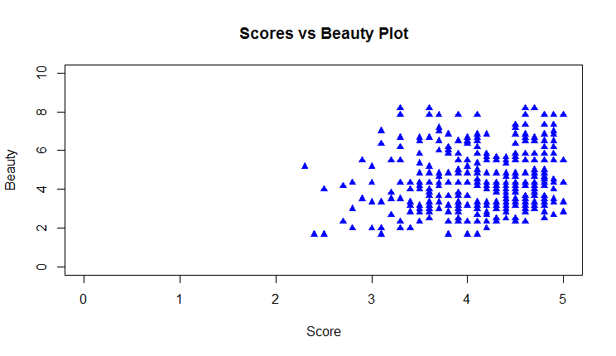
> library(ggplot2)
> dat <- data.frame(score, bty_avg)
> ggplot(dat, aes(x=score, y=bty_avg)) + geom_point(color="red") + geom_smooth(method = lm) +
+ labs(x="Score", y="Beauty Average", title="Beauty Average vs. Score")

Linear Regression Line
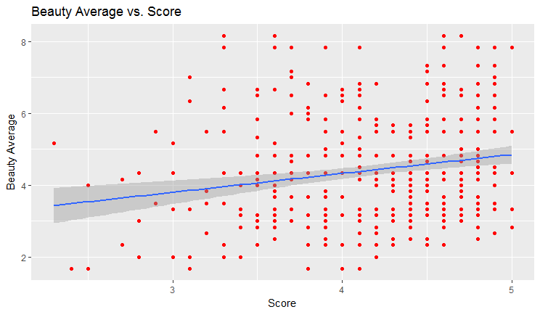
Problem 3: Describe the gender of professors using a table and a bar plot. Make sure the table and plot are properly labeled and titled!
gndr <- table(gender)
gndr
> gndr
gender
female male
195 268

> barplot(gndr, main="Gender", xlab="Gender", col = c("pink", "blue"))
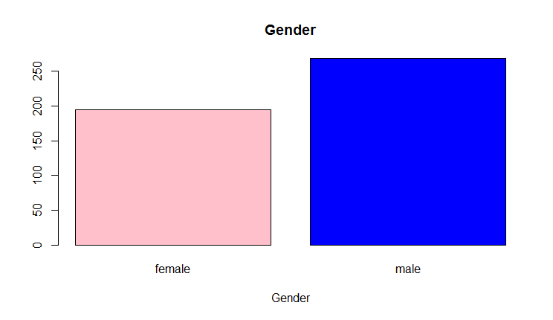
Problem 4: Describe the relationship between course evaluation scores and gender of the professor by creating a side-by-side boxplot. Also visualize the distributions of course evaluation scores by gender using two histograms in the same graphics window. For both the histograms and boxplot, change the color and titles of the graphs. Do males or females get higher course evaluations, on average? Is it a statistically significant difference?
Males get higher course evaluation on average. There is a statistically significant difference as indicated by the T-value of -2.75 and p-value of 0.006 from the t test below. .
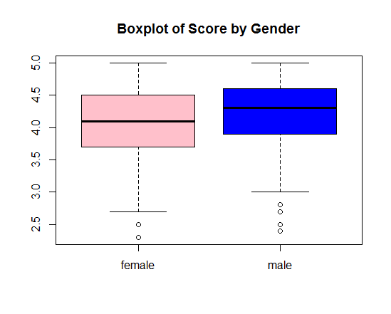
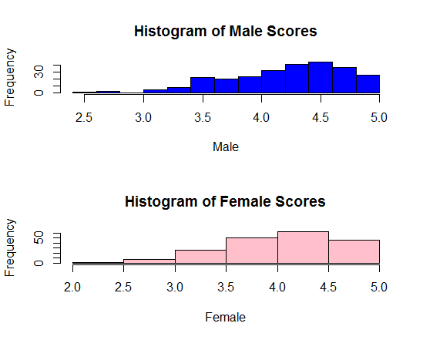
> t.test(score[gender=="female"], score[gender=="male"])

Welch Two Sample t-test

data: score[gender == "female"] and score[gender == "male"]
t = -2.7507, df = 398.7, p-value = 0.006218
alternative hypothesis: true difference in means is not equal to 0
95 percent confidence interval:
-0.24264375 -0.04037194
sample estimates:
mean of x mean of y
4.092821 4.234328

> t.test(score~gender, data=evals)

Welch Two Sample t-test

data: score by gender
t = -2.7507, df = 398.7, p-value = 0.006218
alternative hypothesis: true difference in means is not equal to 0
95 percent confidence interval:
-0.24264375 -0.04037194
sample estimates:
mean in group female mean in group male
4.092821 4.234328
Problem 5: Describe the relationship between rank of the professor and the level of the course by generating a two-way table and a clustered bar plot. Add a title to the clustered bar plot. Add a legend to the plot describing the bar colors of each group.

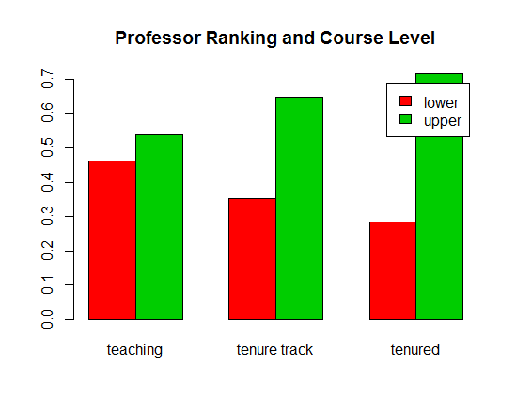

Shows that as the more tenure the more likely the professor would teach a upper level course. 70% of tenured professors teach higher level courses.

References
Hamermesh, Daniel S., and Amy Parker. 2005. “Beauty in the Classroom - Instructors’ Pulchritude and Putative Pedagogical Productivity” 24 (4). Economics of Education Review: 369–76. doi:10.1016/j.econedurev.2004.07.013.

